**ENTRY LEVEL UDEMY DATA ANALYSIS INSIGHT**

Question:

1. What are the total numbers of subscribers in each subject?
2. How does the average content duration/price/number of students vary across different subjects?
3. How many courses are free and paid for each subject?
4. What is the average cost of web development courses at different levels?
5. What are the 20 most popular courses? Also, include the following information:

* Their level
* Whether they are free or paid
* Whether any are free beginner courses
* Duration of the course

**Insight**

1. What are the total numbers of subscribers in each subject?

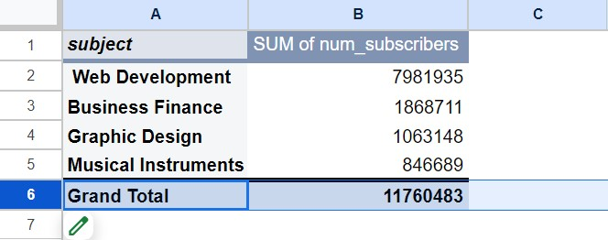

We can see that web development has the most number of subscribers. Followed by business finance. The subscribers for the other two subjects are quite less compared to web development.

1. How does the average content duration/price/number of students vary across different subjects?

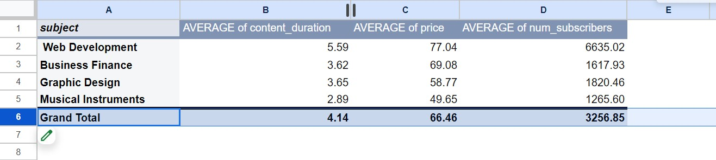

The pivot tables give us clear insight that the average price, content duration and also the number of subscribers are the highest for web development.

1. How many courses are free and paid for each subject?

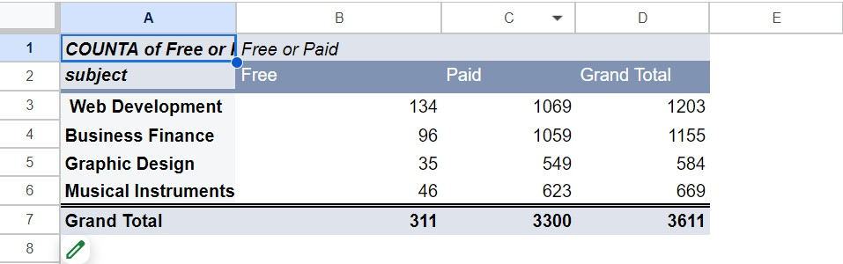

Web development and business finance have more courses than the rest, which is almost 60% of the all courses combined in the database.

1. What is the average cost of web development courses at different levels?

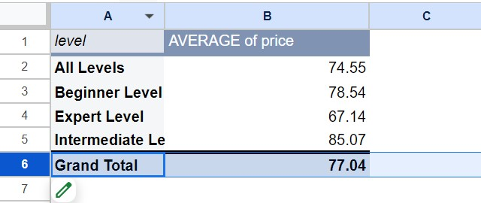

The average cost of all levels for web development is 74.55. The intermediate level has a higher average cost compared to beginner and expert level.

1. What are the 20 most popular courses? Also, include the following information:

* Their level
* Whether they are free or paid
* Whether any are free beginner courses
* Duration of the course

First of all here the top 20 popular courses (the more number of subscriber the course has, the more popular it is).

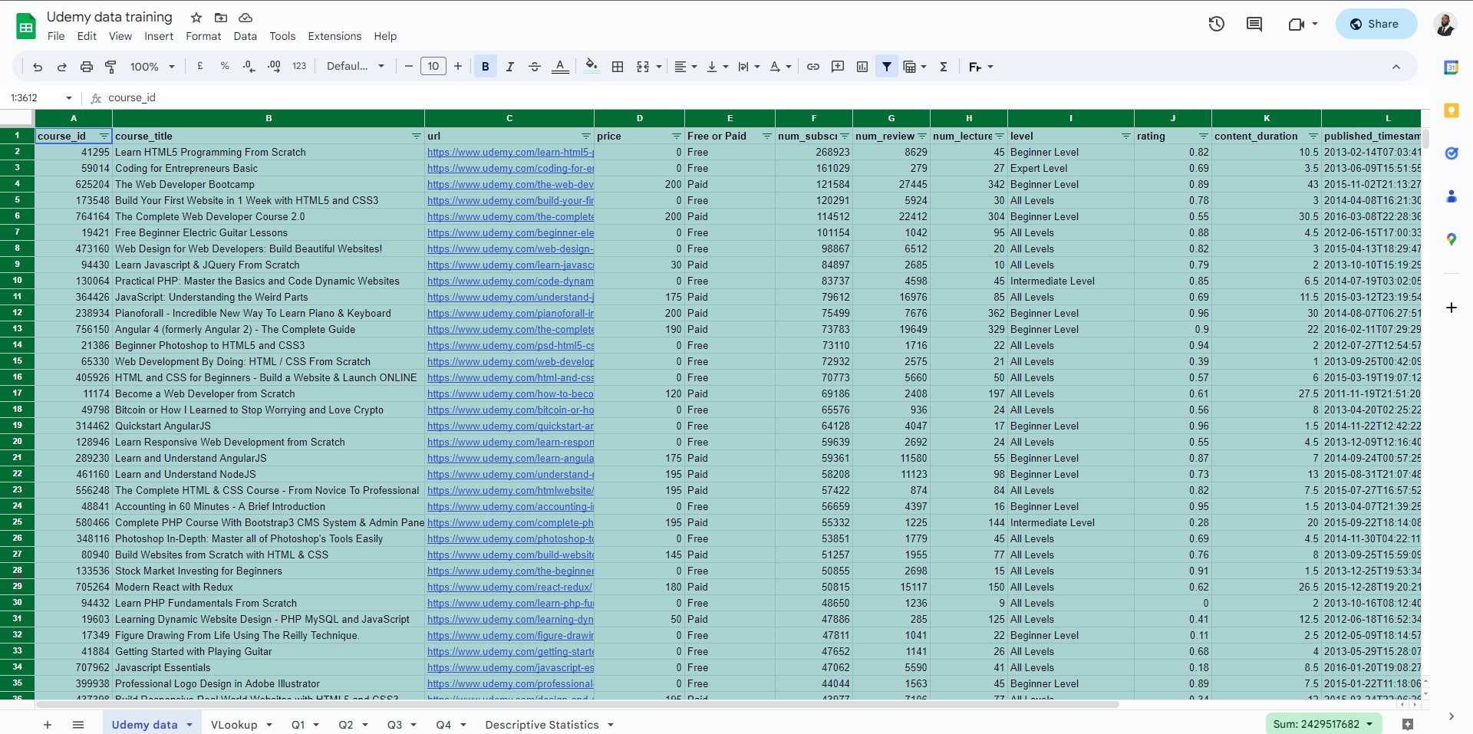

Including their level, free or paid, whether any are free beginner courses, duration of the course.

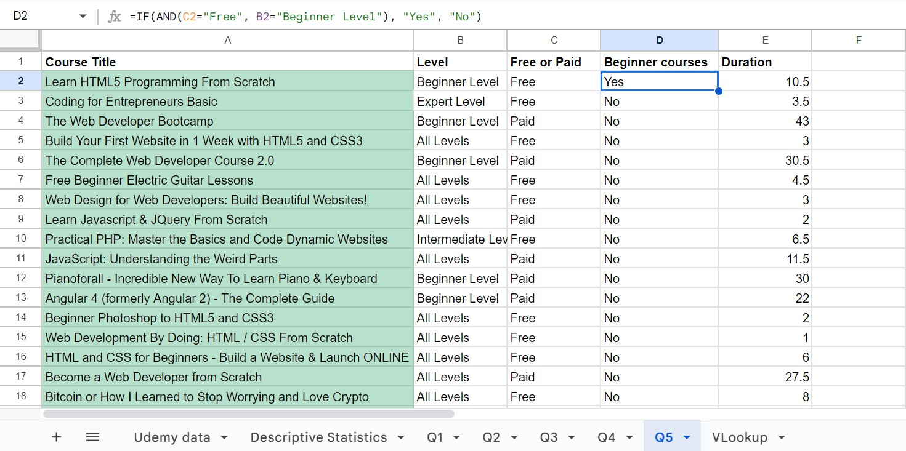

Due to the query above we can notice that the course title “Learn HTML5 programming from scratch” is the most popular due to the fact he is free and beginner friendly.

**Data Visualisation**

Question 1

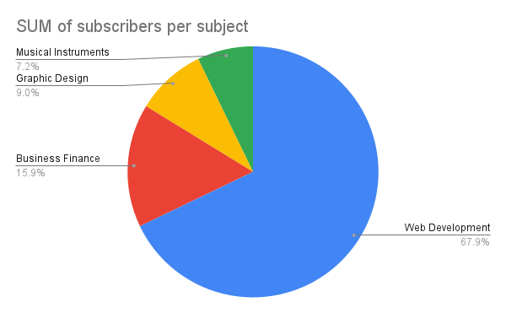

Question 2: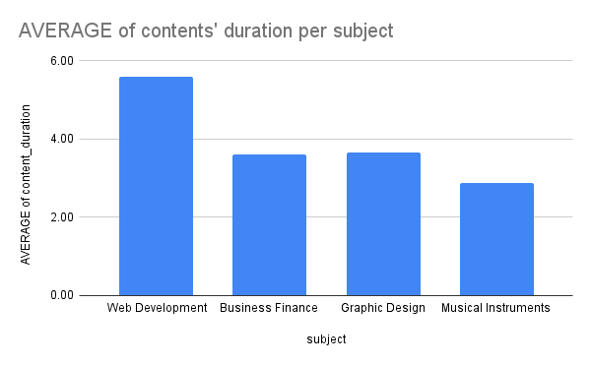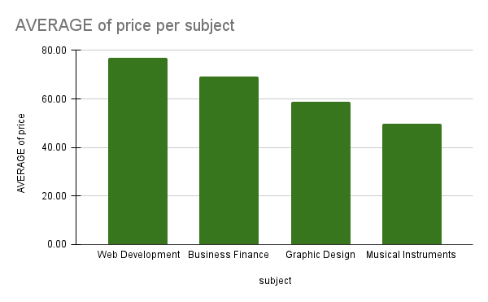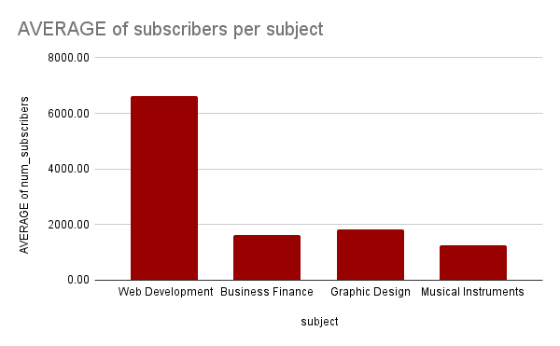

Question 3:

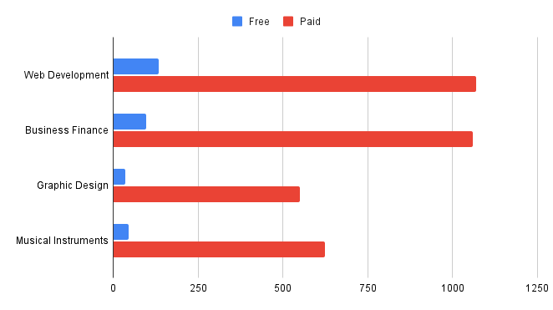

Question 4

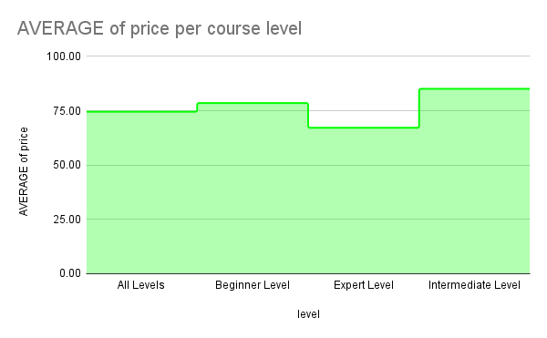

Question 6:

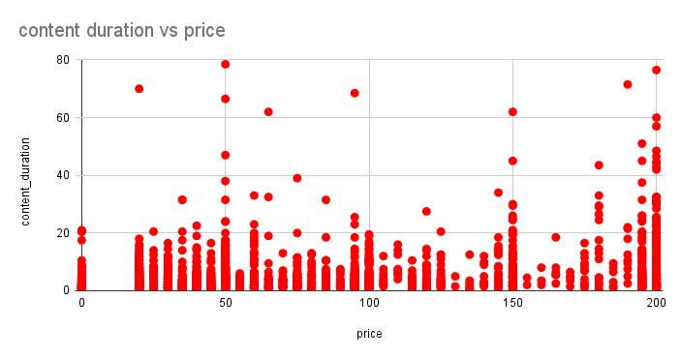

**FIVE WHYS ANALYSIS**

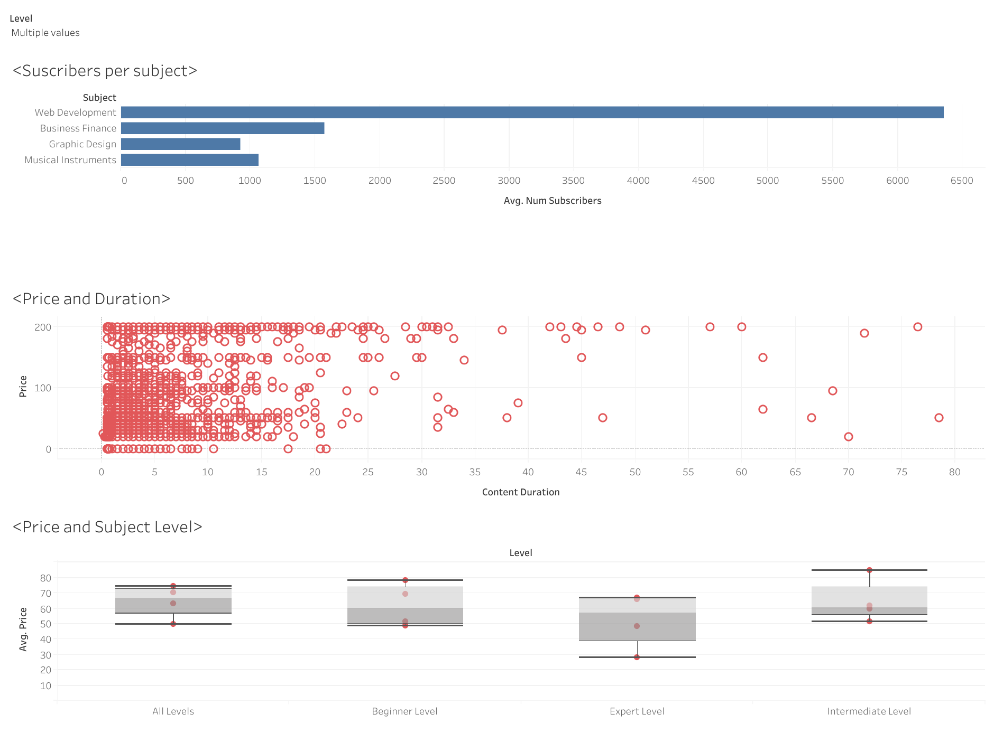

According to the first bar chart of the number of subscribers to subject, it is obvious that web development has a large number of subscribers, and why web development subject has a massive amount of subject compared to the rest of the subject in the database???

Based on the top 20 courses in the udemy database, “Learn HTML5 Programming From Scratch” is the first on the list has an amount of 268923 subscribers, which is approximatively 2% of the total subscribers. The reason why this course has the most subscribers compared to other courses, is the fact that the subject is free and beginner friendly.